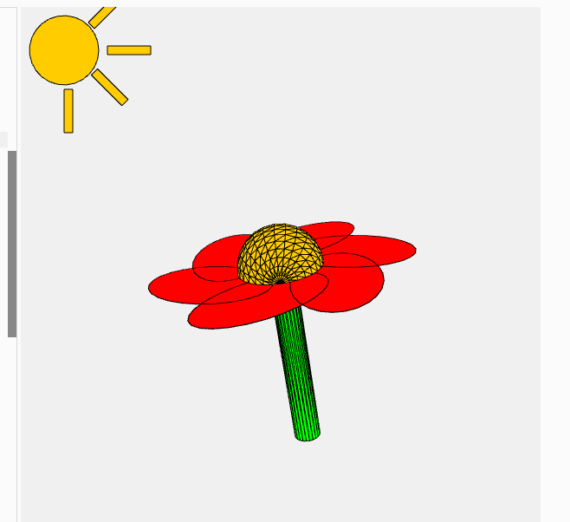

**let angle = 0;  
let scaleFactor = 2;  
let translateX = 0;  
let translateY = 0;  
let petalColor;**

**function setup() {  
createCanvas(600, 600, WEBGL);  
petalColor = color(255, 0, 0);  
}**

**function draw() {  
background(240);  
  
push();  
fill(255, 204, 0);  
translate(-250, -250, 0);  
ellipse(0, 0, 80, 80);  
  
push();  
translate(50, 0);  
rect(0, -5, 50, 10);  
pop();  
  
push();  
translate(35, 25);  
rotateZ(PI / 4);  
rect(0, -5, 50, 10);  
pop();  
  
push();  
translate(35, -25);  
rotateZ(-PI / 4);  
rect(0, -10, 50, 10);  
pop();  
  
push();  
rect(0, 45, 10, 50);  
pop();  
  
pop();  
  
translate(0, translateY);  
scale(scaleFactor);  
rotateX(angle/2);  
rotateY(angle/5);  
  
push();  
fill(0, 255, 0);  
translate(0, 0, 50);  
rotateX(HALF_PI);  
cylinder(8, 130);  
pop();**

**for (let i = 0; i < 6; i++) {  
push();  
fill(petalColor);  
rotateZ(TWO_PI * i / 6);  
translate(30, -30);  
ellipse(0, 0, 50, 80);  
pop();  
}**

**push();  
fill(255, 204, 0);  
sphere(25);  
pop();  
  
angle += 0.02;  
}**

**function keyPressed() {  
if (keyCode === RIGHT_ARROW) {  
translateX += 10;  
} else if (keyCode === LEFT_ARROW) {  
translateX -= 10;  
} else if (key === '+') {  
scaleFactor += 0.1;  
} else if (key === '-') {  
scaleFactor -= 0.1;  
}  
}**

**function mousePressed() {  
if (mouseButton === LEFT) {  
petalColor = color(random(255), random(255), random(255));  
}  
}**